CHAPTER 1
INTRODUCTION

Elevators have become an integral part of modern infrastructure, providing rapid and convenient vertical transportation for millions of people every day. With the growth of urban environments, high-rise residential complexes, commercial buildings, hospitals, shopping malls, and institutional structures, the reliance on elevators has increased dramatically. As these systems are constantly in use, there is a growing emphasis on enhancing their performance, reliability, and safety. Among all safety considerations, monitoring and controlling the load inside the elevator cabin is one of the most essential aspects, as overload conditions can pose serious risks to both users and the mechanical components of the elevator system.

A conventional elevator is equipped with a rated capacity that specifies the maximum allowable weight or the maximum number of passengers that can be safely transported on a single trip. Exceeding this limit may result in excessive strain on the suspension of ropes, traction systems, motors, and control mechanisms. It also increases the chances of operational failures such as abrupt halts, cable fatigue, and overheating of the drive system. To prevent these hazards, modern elevators are designed with advanced load detection systems that automatically restrict movement when the cabin is overloaded. Inspired by this real-world safety feature, the proposed mini project titled “Elevator System with Load Detector” aims to develop a functional prototype that demonstrates the principle of load monitoring and safe elevator operation in a simplified environment.

This project simulates the essential functionalities of an elevator system using embedded electronics, sensors, motors, and a microcontroller-based control mechanism. The elevator cabin movement is replicated using motors, while the load sensing mechanism is implemented using sensors such as load cells or proximity-based passenger detectors. The core objective of this project is to detect the load inside the cabin, compare it with a predefined safe threshold, and, if necessary, halt the elevator movement while issuing a warning signal. Such an implementation not only ensures operational safety but also educates students and developers about intelligent control logic, automation principles, and sensor integration.

In real-world applications, elevator load detection is achieved using load weighing devices installed beneath the cabin or integrated into the elevator suspension system. These sensors measure the strain exerted by the weight of passengers and provide real-time feedback to the elevator control panel.

The project also highlights the importance of embedded system design in modern automation solutions. Embedded controllers such as Arduino, ESP32, or similar microcontrollers play a crucial role in interpreting sensor data and controlling hardware components. The control logic must be carefully designed to ensure that the elevator operates smoothly, responds accurately to floor selection inputs, and enforces safety mechanisms at the right time. The integration of motors, limit switches, and sensor-based feedback systems provides an opportunity to understand practical challenges like signal noise, calibration errors, synchronization delays, and mechanical constraints.

From a broader perspective, load detection in elevators is not only a safety measure but also a key factor in energy efficiency. When an elevator is overloaded, the motor must exert more force to lift the cabin, resulting in increased energy consumption, heat generation, and strain on components. Efficient load management helps reduce wear and tear, extend the lifespan of mechanical parts, and minimize maintenance costs. Therefore, incorporating load detection systems align with the goals of sustainable engineering and green building technologies.

As buildings become smarter and more interconnected, elevator systems are evolving to integrate advanced monitoring and automation features. Smart elevators now communicate with building management systems, adjust travel patterns based on peak hours, and provide predictive maintenance alerts. The prototype developed in this project represents an initial step toward such intelligent systems by demonstrating the integration of sensors, controllers, and electromechanical components to achieve a basic level of automation and decision-making.

As buildings become smarter and more interconnected, elevator systems are evolving to integrate advanced monitoring and automation features. Smart elevators now communicate with building management systems, adjust travel patterns based on peak hours, and provide predictive maintenance alerts. The prototype developed in this project represents an initial step toward such intelligent systems by demonstrating the integration of sensors, controllers, and electromechanical components to achieve a basic level of automation and decision-making.

The “Elevator System with Load Detector” prototype is designed to operate on simple inputs such as user-selected floor buttons. When a floor is selected, the microcontroller processes the request and activates the motor to simulate movement. Simultaneously, the load detection module continuously monitors the weight inside the cabin. If the load remains within safe limits, the elevator continues its operation normally and stops upon reaching the selected floor. However, if at any moment the load exceeds the permissible threshold, the system triggers an alert using visual indicators like LEDs or LCD displays and audio signals such as a buzzer. The motor operation is disabled to prevent the elevator from moving under unsafe conditions. This approach ensures that the system behaves similarly to real elevators which prioritize passenger safety over movement.

One of the key motivations behind this project is its relevance to real-world engineering and its practical implementation value. Load detection systems are indispensable in environments where elevators are frequently used, such as shopping malls, hospitals, hostels, and office buildings. Understanding their working principle helps engineers develop more reliable, safe, and user-friendly transportation systems. Additionally, the project provides hands-on experience in designing systems that combine hardware and software components, encouraging problem-solving and innovative thinking.

The project also emphasizes modularity, allowing for easy expansion or modification. For example, the basic prototype can be upgraded to include multiple floors, automatic door control, voice alerts, IoT-based load monitoring, emergency braking mechanisms, and mobile app integration. Such expansions pave the way for more advanced versions of the system that resemble commercial-grade elevator operations. Therefore, this mini project forms a strong foundation for further research and development in the domain of mechatronic systems and smart automation.

On an academic level, the project aligns with the learning objectives of embedded systems, sensor interfacing, electromechanical control, and safety engineering. It reinforces concepts such as analog- to-digital conversion, threshold comparison, motor driving circuits, calibration techniques, and error handling. Additionally, it allows students to understand the importance of systematic testing, debugging, and documentation in engineering projects. The experience gained through this project enhances practical knowledge and prepares learners for future challenges in industrial automation and real-time system design.

In conclusion, the “Elevator System with Load Detector” project is a simple yet powerful demonstration of the integration of safety, automation, and control technologies. By replicating real- world elevator functionalities on a small scale, the project offers insights into mechanical design, electronic interfacing, load sensing, and intelligent decision-making. It contributes to the understanding of how safety mechanisms play a vital role in preventing accidents and ensuring efficient operation. The prototype also serves as a steppingstone toward more advanced automation solutions and highlights the growing importance of intelligent systems in improving everyday life.

Key Features
- Load Detection System: Measures the cabin load using Proximity sensors and ensures the elevator doesn't operate if overloaded.

- Floor Navigation Logic: Simulates elevator movement across multiple floors using motors and control logic.

- Safety & Alert Mechanism: Triggers warnings when the load exceeds the limit, enhancing the safety of the system.

CHAPTER 2
Literature Survey
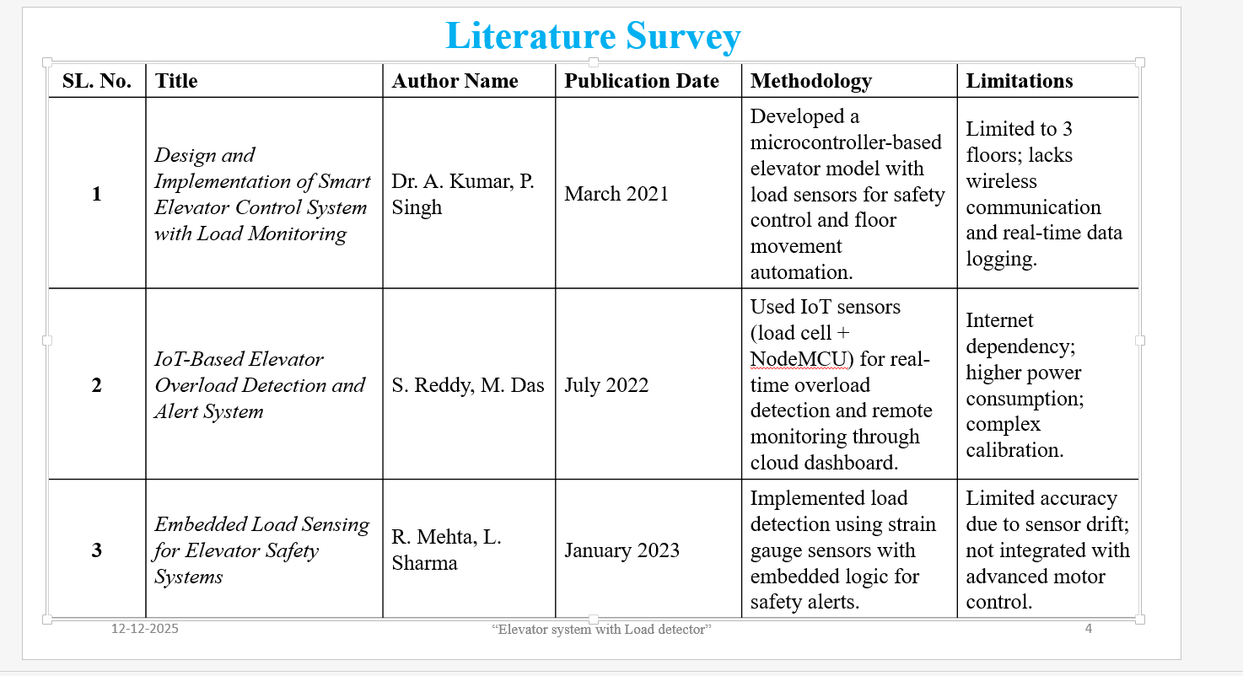

1. Evolution of Elevator Technology
The development of elevator systems has undergone major transformations from simple mechanical hoisting devices to highly advanced automated transportation systems. Early elevators were purely mechanical, lacking sensors, electronics, and intelligent controls. As buildings grew taller and population density increased, the demand for safer and more reliable vertical transportation became a priority. Researchers and engineers began focusing on automation, system efficiency, and user safety. Over the years, technological advancements such as electrically driven motors, automated door systems, and sensor-based controls revolutionized elevator operations. The literature emphasizes that one of the most crucial improvements to modern elevators is the integration of load detection systems, which prevent overloading, reduce mechanical failures, and ensure smooth operation. Numerous studies highlight that load-related issues were historically responsible for frequent breakdowns, increased maintenance needs, and unsafe passenger conditions. These findings underscore the importance of intelligent load monitoring in contemporary elevator design.

2. Importance of Load Detection in Elevators
Scientific and engineering literature consistently emphasizes the significance of load detection as a core safety requirement in elevator systems. Load detection enables the elevator to estimate the total weight present in the cabin and determine whether it exceeds the rated capacity. Research shows that when elevators operate under overload conditions, the motor experiences excessive torque, ropes undergo increased stress, and braking mechanisms become less effective. This can lead to overheating, mechanical deformation, and even catastrophic system failures. Scholars have therefore recommended the use of strain gauges, load cells, and pressure-based sensors to ensure precise and real-time weight measurement. Several works discuss how load cells, due to their high sensitivity and linear performance, outperform other weight-sensing methods. Additionally, studies reveal that passengers often ignore displayed load limits, making automated overload prevention systems essential. These systems issue visual or audio warnings, restrict motor movement, and prevent the elevator from moving until the load is reduced. Literature also highlights that reliable load detection enhances passenger confidence and reduces long-term maintenance costs.

3. Microcontroller-Based Elevator Automation
The shift from relay-based control systems to microcontroller-based automation represents a major milestone in elevator engineering. Modern studies show that microcontrollers such as Arduino, PIC, and ESP32 offer cost-effective, flexible, and programmable solutions for implementing elevator logic. Researchers highlight that microcontrollers enable multiple advanced functions, including load monitoring, motor control, door coordination, floor prioritization, emergency handling, and fault detection. In the context of load detection, microcontrollers interface with sensors like load cells through amplifiers such as HX711, which provides high-resolution analog-to-digital conversion. Literature confirms that microcontroller-based systems ensure quick processing of load data and enhance decision-making accuracy, especially during overload conditions. This shift toward embedded control systems also promotes modular design, easier maintenance, and the integration of intelligent algorithms. Several academic prototypes demonstrate successful elevator models using microcontrollers to combine logic control, motor driving, and safety features into a single synchronized system.

4. Load Detection Techniques and Sensor Technologies
A significant portion of research focuses on the various methods used to detect elevator cabin load. The most commonly recommended technology is the strain-gauge-based load cell, which converts mechanical deformation into electrical signals proportional to the applied weight. Studies praise load cells for their high accuracy, durability, and stability. The HX711 signal amplifier is frequently mentioned in literature for its ability to provide 24-bit precision readings, making it suitable for applications requiring fine weight measurement. Other techniques explored by researchers include piezoelectric sensors, pressure pads, infrared occupancy counters, and floor displacement sensors. However, most comparative studies conclude that these alternatives either lack accuracy or are difficult to calibrate in changing environmental conditions. Thus, the load cell remains the preferred choice for elevator safety systems. Literature also discusses the importance of proper calibration, filtering, and noise reduction techniques to ensure consistent measurement accuracy. Many experimental models in research papers use load cells to demonstrate overload detection in scaled-down elevator prototypes, emphasizing their reliability and ease of integration.

5. Motor Control and the Role of Load Feedback
Another major area covered in elevator research involves the analysis of motor performance under varying load conditions. Elevators typically use AC induction motors, DC motors, or stepper motors depending on their design. Literature highlights that motor torque, speed, and power consumption change significantly with cabin weight. When an elevator is overloaded, the motor requires much higher torque to lift the weight, which can cause overheating and reduce motor lifespan. This is where load detection becomes essential. Studies show that load feedback allows the system to regulate motor speed, control acceleration profiles, and ensure smooth braking. In modern high-rise buildings, variable frequency drives (VFDs) are used to maintain efficient and stable motor operation. Researchers emphasize that integrating load sensing with VFD control provides smoother ride quality, reduced jerking, and improved energy efficiency. Several studies demonstrate that elevators equipped with load-based motor control consume less power and experience fewer mechanical failures, highlighting the strong relationship between load sensing and overall system performance.

6. Safety Measures and User Interaction in Modern Elevators
Safety remains one of the most thoroughly discussed topics in elevator-related research. Several studies reveal that users often disregard posted load limits, making automated overload-detection mechanisms essential for preventing accidents. Literature shows that modern elevators use a combination of audible alarms, digital indicators, and door-lock systems to alert users during overload conditions. When the cabin weight exceeds the safe limit, the elevator automatically blocks door closure or prevents movement, ensuring passenger safety. Researchers also highlight the psychological aspect of elevator usage, explaining how clear warnings and visual cues improve user compliance. Many works reference ISO 4190 and other international safety standards, emphasizing their guidelines for overload detection, emergency communication systems, and cabin balancing. As smart buildings become more common, researchers propose integrating IoT-based monitoring and predictive maintenance systems. By analyzing load patterns over time, these systems can detect unusual behavior, predict component wear, and reduce downtime, thereby enhancing both safety and operational reliability.

7. Energy Efficiency and Future Trends in Elevator Load Management
Energy efficiency is another important theme in modern elevator literature. Studies point out that elevators operate continuously and account for a significant portion of a building’s energy consumption. Load feedback enables elevators to adjust motor power dynamically, reducing unnecessary energy use when the cabin is lightly loaded. In some advanced systems, regenerative braking converts excess mechanical energy into electricity, which can be reused within the building. Literature stresses that accurate load sensing is essential for optimizing regenerative energy production. Recent research trends also include the integration of artificial intelligence and machine learning for real-time load prediction, anomaly detection, and optimization of elevator dispatch algorithms. Scholars predict that future elevators will rely heavily on sensor fusion, IoT connectivity, and AI-based control to achieve higher efficiency, enhanced safety, and improved user experience.

CHAPTER 3
Problem Statement

1. Background of the Problem
In today’s rapidly urbanizing world, multi-storey buildings such as apartments, hospitals, commercial complexes, and educational institutions rely heavily on elevators for efficient vertical transportation. As the number of elevator users continues to increase, the mechanical and electrical load on elevator systems also rises. One persistent issue affecting elevator safety and performance is the problem of overloading. Although most elevators display a rated maximum load, passengers often overlook these instructions, leading to situations where elevators operate under unsafe weight conditions. Such practices put immense strain on the motor, cables, pulleys, and braking systems, ultimately resulting in frequent breakdowns and increased maintenance costs. Traditional elevator systems were designed with limited sensing capabilities and lack the ability to accurately detect real-time load variations, especially under dynamic conditions when multiple passengers enter or exit. This gap in detection technology has created a need for smarter and more reliable safety mechanisms to protect passengers and prevent mechanical failures.

2. Existing Limitations in Conventional Elevator Systems
Conventional elevators in many buildings still depend on outdated relay-based or mechanically balanced load systems that cannot precisely measure the actual weight inside the cabin. These traditional mechanisms often function only as rough indicators and do not actively influence the elevator’s operational decision-making. In some installations, overload indicators may exist, but they merely warn passengers without restricting elevator movement. As a result, elevators may still attempt to operate with excessive loads, causing the motor to draw higher currents and increasing the likelihood of overheating or system halting. Moreover, mechanical pressure-based systems are prone to calibration errors, wear over time, and reduced accuracy under varying environmental conditions. The inability of these systems to respond promptly or accurately to overload situations represents a significant safety gap. This is especially critical in high-traffic places such as malls and universities where peak load conditions occur frequently. Without a dependable and automated load sensing mechanism, elevator performance becomes unpredictable, posing safety risks and potential financial implications due to equipment failure.

3. Safety Concerns and Operational Challenges
Safety hazards arising from elevator overloading are well-documented in engineering studies. When an elevator exceeds its rated capacity, the motor experiences excessive torque demand, which can lead to stalling or abrupt stoppage. Additionally, the braking system may become less effective, thereby increasing the chances of uncontrolled descent or mid-floor halts. These situations can cause panic among passengers and compromise user confidence. Human behavior also contributes to these challenges, as users tend to crowd into elevators during busy times to minimize waiting periods. Without an automated system to detect and respond to overload, elevators remain vulnerable to unsafe operation. The absence of real-time monitoring also hinders building management’s ability to implement preventive maintenance. Malfunctions related to overloading often go unnoticed until major breakdowns occur. Therefore, it is crucial to introduce an intelligent system capable of monitoring the cabin load continuously and reacting instantly by preventing elevator movement, alerting passengers, and ensuring compliance with safety limits.

4. Need for an Intelligent Load Detection Solution
Given the limitations of traditional elevators and the safety hazards associated with overloading, there is a clear need for an improved elevator system equipped with a precise and automated load detection mechanism. Such a system should utilize modern sensor technologies, such as load cells, paired with a microcontroller to provide accurate, real-time measurement of cabin weight. The solution must be capable of processing sensor data instantly and initiating safety protocols, including audible or visual alerts and movement restrictions. Integrating load detection with a microcontroller-based control unit ensures better reliability, faster response, and enhanced decision-making compared to conventional systems. This smart elevator system would not only prevent accidents but also improve operational efficiency by reducing unnecessary strain on mechanical components. It would extend the lifespan of motors, cables, and braking systems while minimizing maintenance costs. Therefore, the central problem addressed by this project is the lack of an effective, intelligent load detection and control mechanism within elevator systems, which is essential for ensuring safe, efficient, and reliable vertical transportation in modern buildings.

Chapter 4: Block Diagram
4.1 Block diagram
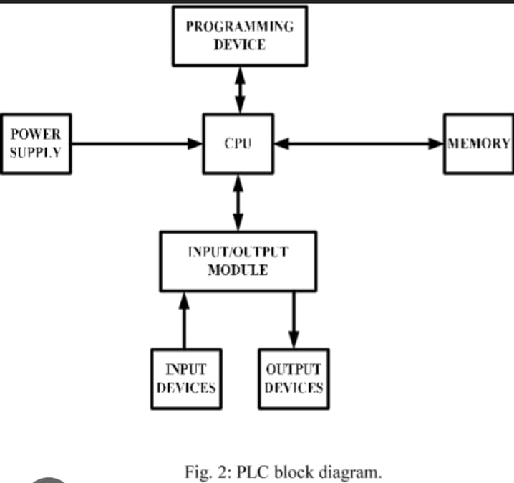

The block diagram of the Elevator System with Load Detector represents the functional flow of the entire project, showing how each subsystem interacts to achieve safe and efficient elevator operation. At the core of the system is the microcontroller, which acts as the central processing unit. It receives inputs from sensors, processes the information, and controls the motor and display outputs. The microcontroller is responsible for executing programmed logic related to load detection, floor selection, motor direction control, and safety mechanisms. All other blocks in the system are directly or indirectly connected to the microcontroller, making it the brain of the entire setup.
One of the most important components in the block diagram is the Load Cell and HX711 Amplifier Module. The load cell senses the weight of the passengers or items inside the elevator cabin, converting the mechanical force into a small electrical signal. This signal is extremely weak, so it is fed into the HX711 load cell amplifier, which boosts it and converts it into a digital format. This processed output is sent to the microcontroller, where it is continuously monitored to determine whether the load is within a safe operating limit. If the weight exceeds the predefined threshold, the microcontroller activates the overload protection system.
Another essential block is the Floor Selection Unit, which consists of buttons or switches representing different floors. When a user presses a button, the signal is sent to the microcontroller, which determines the target floor and the direction of movement. The microcontroller then activates the Motor Driver Block (usually an L298N) to control the elevator motor. The motor driver receives control signals from the microcontroller and supplies the required voltage and current to the motor for lifting or lowering the elevator cabin. This arrangement ensures smooth and controlled operation while protecting the microcontroller from high motor currents.
To track the position of the elevator, the block diagram includes Floor Sensors or Limit Switches. These sensors are placed at each floor level and send feedback signals to the microcontroller whenever the elevator reaches a particular floor. This allows the system to stop the motor at the correct position and ensures accurate leveling of the cabin. Without these sensors, the elevator would not be able to determine its location, which is essential for safe operation.
The Display and Buzzer Block plays an important role in user communication and safety. The display (LCD or OLED) shows information such as current floor number, load value, and overload warning messages. The buzzer provides audible alerts in case of overload or system faults. These alert systems help passengers understand the status of the elevator and respond accordingly.
Finally, the Power Supply Block ensures stable and reliable power for all components. The microcontroller, sensors, HX711 module, and display typically operate on 5V, while the motor driver and motor may require 12V. The power supply ensures that each block receives the appropriate voltage, and grounding is shared across all modules to maintain a common reference point for accurate operation.
Overall, the block diagram clearly illustrates how each subsystem works together to achieve safe, intelligent, and efficient elevator control. The load detection block ensures safety, the motor driver enables movement, the sensors provide feedback, and the microcontroller ties everything together through logic and decision-making.

4.2 Operation

1. System Initialization and Startup Process

The operation of the Elevator System with Load Detector begins the moment the system is powered on. During the initialization stage, the microcontroller performs a series of internal checks, activating all input and output devices to confirm proper functioning. The load cell and HX711 amplifier module begin sampling the weight placed on the elevator cabin platform. This initialization also includes sensor calibration processes to ensure that accurate readings are captured from the very first moment. Floor sensors, limit switches, the motor driver, and the display unit are also activated and made ready for operation. The microcontroller loads preset values such as the maximum allowable load and floor height data into its memory. If any component fails to respond during initialization, the system enters an error-handling mode, preventing the elevator from moving until the issue is resolved. This ensures that the elevator system starts with complete functional readiness, reducing operational risks and enhancing user safety.
During startup, the load cell continuously sends electrical signals representing applied weight to the HX711 module. These signals are translated into digital values which the microcontroller uses as the basis for all subsequent operational decisions. The display unit shows the current floor number and system status, indicating that the elevator is ready for use. This preparatory phase ensures that the system will not attempt to move until proper checks are completed, thereby providing a stable and reliable foundation for all elevator operations.

2. Load Measurement and Safety Verification

Once the system is initialized, the next major step in elevator operation is continuous load measurement. The load cell plays a critical role in detecting the weight inside the elevator cabin. As passengers or objects enter the elevator, the load cell experiences mechanical deformation, producing a small analog voltage proportional to the weight applied. The HX711 amplifier boosts this signal and converts it into a high-precision digital reading. These load values are sent to the microcontroller, which checks whether the measured weight falls within the permissible limit. This process ensures that the elevator only operates under safe load conditions.
If the cabin load remains within the allowed threshold, the elevator is permitted to respond to floor selection inputs. However, if the weight exceeds the maximum permitted load, the microcontroller immediately activates the overload protocol. The elevator doors remain open, and the system prevents any movement by disabling the motor driver. An audible buzzer alarm is triggered, and the display shows an “OVERLOAD – PLEASE REDUCE WEIGHT” message. The elevator remains in this locked state until passengers remove the excess weight. Once the load returns to a safe level, the microcontroller verifies the condition and restores normal operational capability. This continuous safety verification ensures that the motor, cables, and braking system are never subjected to dangerous stress levels.

3. Floor Selection and Direction Determination

With load conditions verified, the elevator system becomes ready to accept floor selection inputs from users. When a user presses a button for a desired floor, the microcontroller interprets the request and determines the direction of movement—either upwards or downwards. The decision is based on comparing the current floor position with the selected floor. During this phase, the microcontroller also checks whether the elevator is already in motion or idle. If the elevator is idle and safe, the command is accepted and processed immediately.
Based on the selected floor, the motor driver receives directional control signals. For upward movement, the driver activates the motor to rotate in the forward direction, whereas for downward movement, the motor rotates in reverse. If multiple floor requests are received, the microcontroller stores them in memory and processes them sequentially based on priority or direction logic. This helps optimize elevator movement and reduces unnecessary motor operations. Throughout this process, the microcontroller continuously monitors load readings and floor sensors to ensure that conditions remain safe during travel.

4. Elevator Movement and Real-Time Monitoring

Once the elevator begins to move, the system enters its most dynamic operational phase. The motor, controlled by the L298N or similar driver, gradually accelerates to ensure smooth and jerk-free movement. The speed may be controlled manually using PWM signals or set to a fixed operating speed depending on the design. As the elevator moves vertically, limit switches placed at each floor send position feedback to the microcontroller. This ensures that the system knows the exact current location of the cabin at all times.
Throughout the movement, the microcontroller continuously monitors the load readings to detect any sudden changes in weight. If an overload occurs while the elevator is in motion, the system immediately initiates a safety protocol by slowing down the motor and stopping the elevator at the nearest available floor. The display shows a warning, and the buzzer activates to alert passengers. This real-time monitoring ensures the elevator never operates under unsafe conditions at any point during its travel.
Additionally, obstacle detection (if implemented) and door status sensors ensure that the elevator only moves when doors are closed and no obstructions are present. The microcontroller synchronizes all these sensors to maintain the proper functioning of the system. The system also prevents abrupt stops by smoothly decelerating the motor when approaching the target floor.

5. Floor Detection and Stopping Mechanism

As the elevator approaches a selected floor, the corresponding limit switch is activated, signaling the microcontroller to slow the motor and precisely halt the cabin. The stopping mechanism ensures that the elevator aligns perfectly with the floor level to prevent trip hazards or uneven cabin positioning. The motor is gradually powered down to achieve a soft landing, ensuring comfort and safety for passengers.
Upon reaching the floor, the microcontroller stops the motor completely and checks the load reading once again. The doors then open automatically or through programmed simulation in a prototype. During this time, the system enters a temporary hold state, allowing passengers to enter or exit. The load cell continuously monitors the weight changes during this phase. If an overload occurs when new passengers enter, the elevator remains locked at the floor and displays an overload alert until the load returns to safe levels.

6. Door Operation and User Interaction

Door operation is another important part of elevator functioning. After reaching the target floor, the doors open automatically, allowing movement of passengers. A preset delay keeps the doors open for an adequate time before closing them. The microcontroller verifies load readings and ensures no obstructions are detected before commanding the doors to close. If weight exceeds the limit during entry or exit, the doors remain open and motor operation is restricted for safety.
The OLED/LCD display continuously provides real-time feedback such as current floor, direction of movement, overload status, and system messages. This communication helps passengers understand the elevator’s status clearly and ensures proper user interaction.

7. Return to Idle State and Continuous Loop Operation

After completing a trip and confirming safe load levels, the elevator returns to an idle state, waiting for the next user input. During this idle state, the system keeps monitoring the load cell, limit switches, and user buttons. The process repeats for every new operation, forming a continuous loop of sensing, decision-making, movement, stopping, and alerting.
This continuous operational cycle showcases the integration of microcontroller logic, real-time sensing, motor control, and safety management. Each subsystem functions together to ensure that the elevator operates smoothly, efficiently, and safely at all times. The detailed coordination between load detection, floor control, and movement mechanisms reflects the effectiveness of the system’s design and implementation.

4.3 Hardware components
1. Ardunino nano:
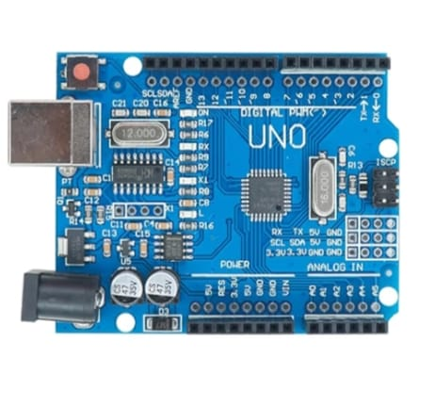
The Arduino Nano is a compact microcontroller board used to control and automate electronic circuits, making it suitable for small embedded systems. The proximity sensor is used to detect the presence of an object without any physical contact, helping the system sense distance or movement. A servo motor provides precise angular motion and is commonly used for controlled movements such as opening or closing mechanisms. The gear motor is a DC motor combined with a gearbox that increases torque and reduces speed, making it suitable for lifting or driving loads. A motor driver acts as an interface that supplies sufficient current to motors, as the Arduino cannot drive them directly. The Arduino IDE software is used to write, compile, and upload programs to the Arduino Nano for proper operation of the entire system.

2. Proximity sensor :
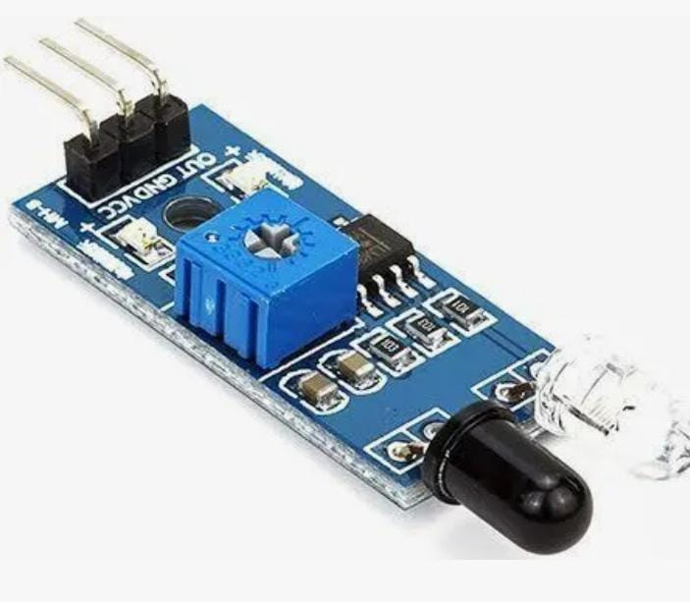
A servo motor is a special type of motor designed to provide precise control over angular or rotational movement. It consists of a small DC motor, a set of gears, a control circuit, and a position sensor. The servo receives a control signal (PWM) that determines the angle at which it should rotate, usually within a range of 0° to 180°. Because of its accuracy, reliability, and fast response, servo motors are commonly used in robotics, automation systems, door mechanisms, and model control systems. They are ideal for applications where controlled and repeatable movements are required.

3. Servo motor:
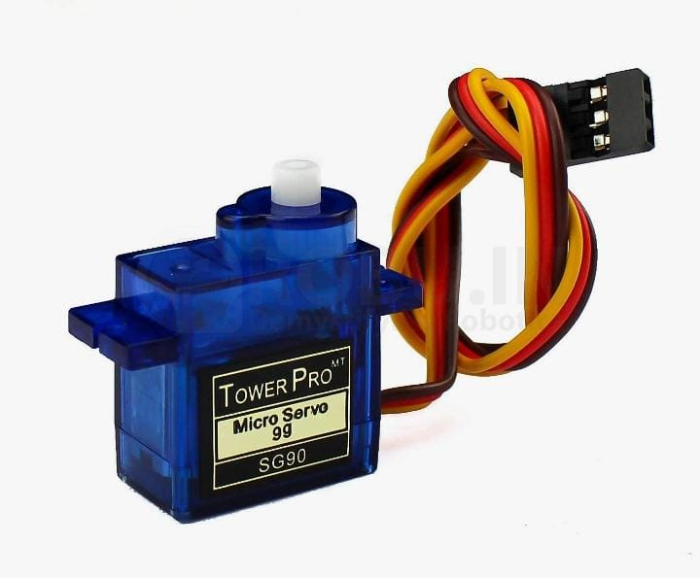

A motor driver is an electronic module used to control and operate motors by acting as an interface between the microcontroller and the motor. Since microcontrollers like Arduino cannot supply the high current and voltage required by motors, the motor driver provides the necessary power while receiving low-power control signals. It allows the motor to rotate in both forward and reverse directions and enables speed control using PWM signals. Motor drivers such as L298N and L293D are commonly used in robotics, automation, and motor-based projects. They protect the microcontroller from damage and ensure smooth, safe, and efficient motor operation.

4. Gear motor:
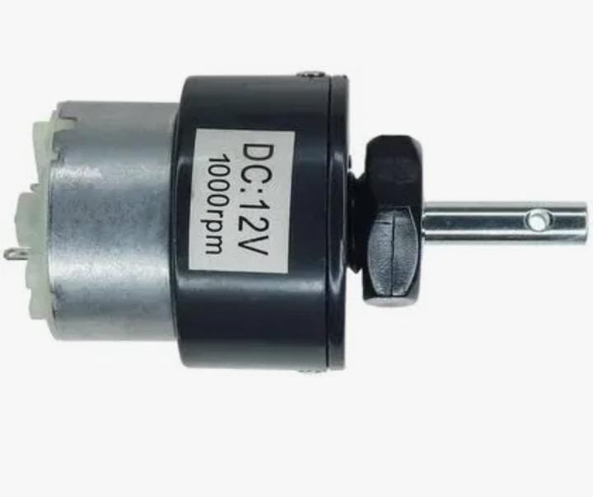
A gear motor is a combination of an electric motor and a gearbox that works together to provide high torque at low speed. The gearbox reduces the motor’s rotational speed while increasing its torque output, making it suitable for driving heavy loads or mechanisms that require strong, controlled movement. Gear motors are commonly used in applications like elevators, robotics, conveyor belts, and automation systems. In small projects, they help move mechanical parts smoothly and with enough force. Because of their durability and efficiency, gear motors are ideal for systems that need consistent speed control and reliable mechanical power.

5.Motor driver:
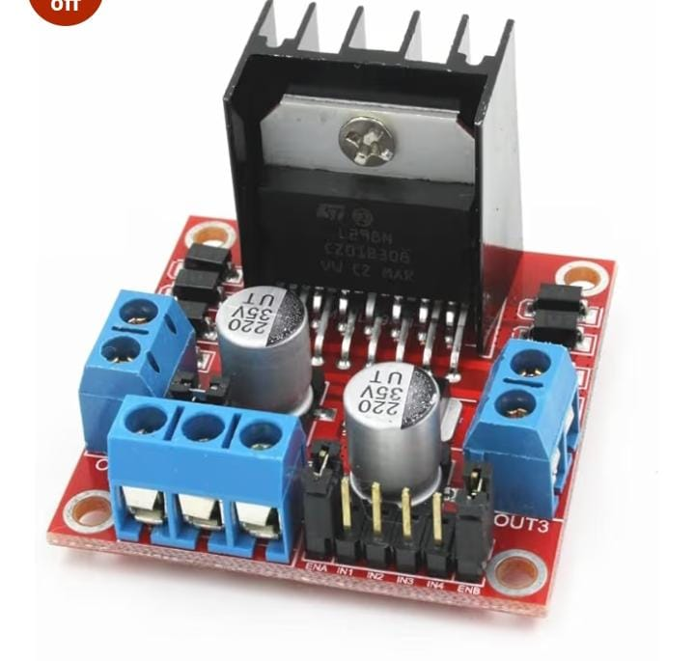
A motor driver is an electronic module used to control and operate motors by acting as an interface between the microcontroller and the motor. Since microcontrollers like Arduino cannot supply the high current and voltage required by motors, the motor driver provides the necessary power while receiving low-power control signals. It allows the motor to rotate in both forward and reverse directions and enables speed control using PWM signals. Motor drivers such as L298N and L293D are commonly used in robotics, automation, and motor-based projects. They protect the microcontroller from damage and ensure smooth, safe, and efficient motor operation.

4.4 Software components
1. Ardunino IDE
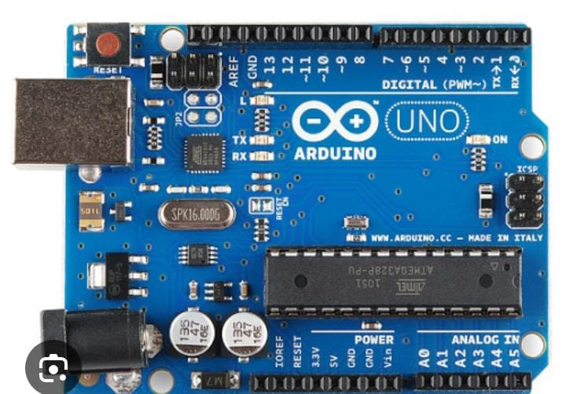

The Arduino IDE (Integrated Development Environment) is the software platform used to write, compile, and upload programs to Arduino boards. It provides a simple and user-friendly interface where users can write code in C/C++ using Arduino libraries. The IDE includes a code editor, a compiler, and a serial monitor for testing and debugging. It also supports adding external libraries to work with different sensors and modules. Through the USB connection, the IDE uploads the compiled program to the Arduino Nano, enabling it to control connected components. Because of its simplicity and flexibility, Arduino IDE is widely used in learning, prototyping, and electronic project development.

Chapter 5: Design, Implementation and Results
5.1 methodology/Circuit diagram and working

5.1.1 METHODOLOGY
The methodology for designing an Elevator System with Load Detector involves a structured approach that combines electronic sensing, microcontroller programming, motor control mechanisms, and safety logic implementation. The development process begins by identifying the major functional blocks required for the elevator, such as the load sensing unit, control system, motor driving circuit, floor sensing mechanism, and alert system. Each block is designed to interact seamlessly with the others to achieve reliable and safe elevator operation. The primary methodology focuses on integrating a load cell with an HX711 amplifier for weight measurement, interfacing this data with a microcontroller such as Arduino or ESP32, and enabling automated decision-making under various load conditions.
Initially, the load cell is calibrated to ensure accurate measurement of cabin weight under different load conditions. Calibration involves applying known weights and adjusting the conversion factor in the microcontroller code until the displayed value matches the actual load. Proper calibration is essential because even small deviations in measurement can affect safety decisions. The next step in the methodology involves programming the microcontroller with logic to continuously monitor load values, detect overload conditions, and control elevator movement accordingly. The program also includes routines for floor selection, motor direction control, door simulation, and emergency handling. Software design includes sensor filtering techniques to eliminate noise and ensure stable readings from the load cell.
Simultaneously, the electrical circuitry is designed to support smooth and fault-free interactions between all components. The motor chosen for the elevator prototype is typically a DC motor or stepper motor controlled through an L298N or similar driver module. The power supply circuit ensures suitable voltage levels for each module, preventing fluctuations that may interfere with sensor accuracy. Limit switches placed at each floor serve as feedback devices to indicate the cabin's current position. The methodology also incorporates the development of alert mechanisms such as buzzers and display modules to notify users during overload conditions. Once the hardware and software are developed, integrated testing is conducted to ensure the system responds correctly under all operating scenarios. This iterative testing and refinement process results in a robust and reliable elevator system equipped with real-time load detection.
    - Circuit diagram

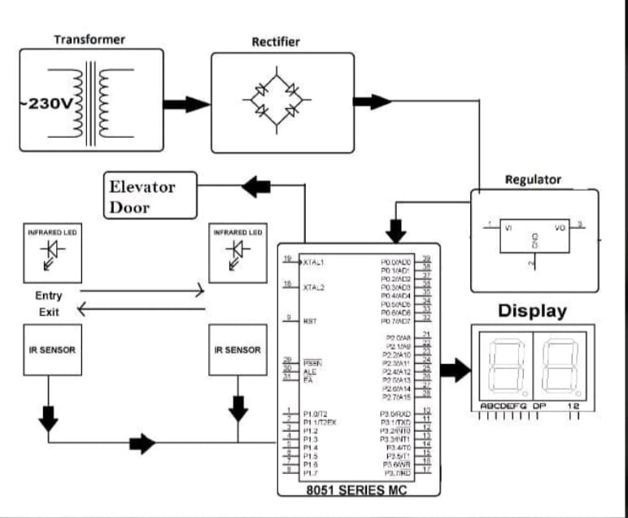

Because diagrams cannot be drawn here, the circuit diagram is explained in a clear text-based layout, showing how each component connects within the system.
• Load Cell → HX711 Amplifier:
The load cell has four terminals: Red (Excitation+), Black (Excitation−), White (Signal−), and Green (Signal+). These are connected to the corresponding E+, E−, A−, and A+ pins on the HX711 module. The HX711 output pins DT and SCK are connected to two digital input pins of the microcontroller.
• HX711 → Microcontroller (Arduino/ESP32):
The DT pin is connected to digital pin D2, and SCK to D3. The VCC of HX711 goes to 5V (or 3.3V for ESP32), and GND is common with the controller.
• Motor Driver (L298N) → Microcontroller:
Two input pins (IN1, IN2) from the motor driver connect to GPIO pins of the microcontroller, enabling direction control. ENA is connected either to a PWM pin for speed control or tied to VCC for constant speed. The motor terminals (OUT1, OUT2) of L298N connect to the elevator motor.
• Power Supply:
The microcontroller receives 5V DC, the L298N receives 12V DC for motor operation, and all grounds are interconnected to establish a common reference point.
• Limit Switches (Floor Sensors):
Each floor has a limit switch connected to digital input pins of the microcontroller. When the elevator reaches a floor, the respective switch activates, signaling position confirmation.
• Display/Buzzer Unit:
An OLED/LCD display is connected through I2C pins (SCL/SDA) to show floor number, load status, and overload warnings. A buzzer is connected to a digital pin to generate alerts during overload.
• Override Safety Circuit:
An emergency stop switch is connected to an interrupt pin of the microcontroller to immediately halt elevator operation if activated.
This textual circuit representation mirrors a full diagram and accurately describes the connections essential for building the prototype.

5.1.3 Working

1. System Initialization and Load Monitoring
The working of the Elevator System with Load Detector begins as soon as the power supply is switched on. During initialization, the microcontroller activates the load cell and HX711 amplifier module to start capturing real-time weight measurements from the elevator cabin. The load cell continuously senses the applied force and converts it into an electrical signal, which is then amplified and digitized by the HX711 before being sent to the microcontroller. The system compares the measured weight with the maximum permissible load stored in its memory. This constant monitoring ensures that the elevator never begins operation under unsafe load conditions. If the load is within the safe limit, the system proceeds to accept user floor inputs; otherwise, it triggers the overload safety protocol.

2. Floor Selection and Direction Control
Once the elevator confirms that the current cabin load is safe, it begins responding to floor selection commands. When a user presses a floor button, the microcontroller receives the signal and determines whether the requested floor lies above or below the current position of the cabin. Based on this decision, the microcontroller activates the L298N motor driver to rotate the elevator motor in the required direction. The motor driver receives digital signals for direction and PWM signals for speed modulation, allowing for smooth and controlled elevator movement. This phase ensures the elevator starts accelerating in the correct direction, maintaining safe operation based on user input and load conditions.

3. Continuous Monitoring During Movement
As the elevator begins moving toward the selected floor, the microcontroller continues to monitor both the cabin load and the cabin position. Limit switches placed at each floor act as reference points and help the system identify the elevator’s current position at all times. The microcontroller ensures that the elevator stops accurately at the correct floor without overshooting. Throughout the movement, the load cell remains active to ensure that no sudden change in weight occurs. If an unexpected overload is detected during the journey, the system responds by stopping the elevator at the nearest safe floor to prevent motor strain or mechanical failure. This function adds an additional layer of safety and reliability.

4. Arrival at Destination and Door Simulation
When the elevator reaches the designated floor, the respective limit switch sends a signal to the microcontroller, prompting the system to gradually reduce the motor speed and bring the cabin to a smooth stop. Once halted, the microcontroller commands the door mechanism (or simulated output in a prototype) to open. The display module shows the floor number and any relevant alerts. The system enters a brief pause period to allow passengers to enter or exit the cabin. During this time, the load cell continues monitoring the weight to ensure that the safe limit is not exceeded before the elevator resumes operation.

5. Overload Detection and Safety Lock Mechanism
One of the most essential aspects of the system’s working is overload management. If the load cell detects that the cabin weight has exceeded the predetermined safety threshold, the microcontroller immediately halts all elevator operations. The doors remain open, and the motor driver is disabled to prevent accidental movement. A buzzer and display alert are activated to inform passengers that the system is in an overload condition. The elevator will not move until the extra weight is removed and the load cell readings return within the acceptable range. This mechanism protects the motor from overheating, prevents cable strain, and ensures the safety of passengers.

6. Return to Idle State for Next Operation
After completing the trip or resolving an overload condition, the system resets itself to an idle state. In this state, the microcontroller waits for the next floor selection input. The load cell continues functioning in the background, ensuring the cabin remains within safe operating limits. This loop continues indefinitely, allowing the elevator to function smoothly, reliably, and safely. Through proper coordination of sensing, decision-making, and motor control, the system maintains consistent performance and enhances elevator safety using modern automation technology.

5.2 Project Implementation

1. Introduction to Implementation
The implementation of the Elevator System with Load Detector involves converting the designed methodology into a fully functional hardware and software model. This stage focuses on assembling the electronic circuits, programming the microcontroller, integrating sensors, testing the motor control system, and ensuring safety protocols operate as expected. The overall aim of implementation is to create a working prototype that demonstrates how real-time load sensing can be combined with automated elevator movement to enhance safety and reliability. The process begins with procuring the required components such as the load cell, HX711 amplifier, microcontroller board, motor driver module, DC motor, limit switches, buzzer, and display unit. Each component is individually tested to ensure proper functioning before the integration stage. Once validated, the components are arranged in a structured layout to mimic the arrangement of an actual elevator system at a smaller scale.

2. Hardware Assembly and Sensor Integration
The first step in physical implementation is building the hardware circuit. The load cell is mounted securely under the elevator cabin platform so that it can detect weight accurately. The load cell’s four terminals are connected to the HX711 amplifier module, which is then linked to the microcontroller through digital input pins. Care is taken to stabilize the load cell mount to reduce vibrations and avoid inaccurate readings. Following this, the L298N motor driver is connected to the microcontroller and the DC motor that drives the elevator cabin vertically. A 12V power supply is used to operate the motor, while the microcontroller and sensors are powered using a stable 5V source. All grounds are tied together to ensure consistent electrical referencing across the system.
Limit switches are placed at each floor level to simulate real elevator floor detection. These switches send digital signals to the microcontroller when pressed, helping the system identify the cabin’s current position. Additionally, an OLED or LCD display is mounted on the prototype to show real-time information such as floor number, load readings, and overload warnings. A buzzer is connected to provide auditory alerts during unsafe conditions. Once all connections are completed, the entire circuit is inspected, and wiring is organized to avoid short circuits or loose contacts.

3. Software Development and Microcontroller Programming
The implementation continues with developing the control software that governs elevator operation. The microcontroller is programmed using Arduino IDE or another embedded programming environment. The software begins with the initialization of input and output pins, sensor calibration routines, and communication protocols for the HX711 module. A load calibration function is included to convert the analog load cell signals into meaningful weight units. The main code contains logic for interpreting floor selection inputs, determining movement direction, activating the motor driver, and using PWM signals to control motor speed.
A continuous loop monitors both load readings and floor positions. If the load exceeds the predefined threshold, the system immediately disables the motor and activates overload warnings. When the load returns to normal, the system allows the elevator to resume movement. The floor detection logic ensures that the elevator stops precisely at each designated point when the corresponding limit switch is triggered. Safety routines are embedded to handle emergency stops, unexpected load variations, or invalid sensor readings. The code is tested multiple times under different scenarios to ensure reliability, responsiveness, and stability.

4. System Integration and Testing
After hardware assembly and software development, the project enters the integration and testing phase. The components are powered on, and the system undergoes initial trials to verify communication between the load cell, HX711 amplifier, and microcontroller. The calibration procedure is carried out to ensure accurate weight readings. Once verified, floor selection buttons are tested to confirm that the microcontroller correctly interprets input commands and moves the elevator accordingly. Load testing is performed by gradually placing weights on the cabin platform. The system must detect even small changes in load and respond appropriately when the overload threshold is crossed.
Motor performance is examined under different load conditions to ensure smooth acceleration, precise stopping, and correct directional movement. Each limit switch is tested individually to verify floor detection accuracy. The overload safety mechanism undergoes repeated tests in which the motor driver must immediately cut off power, the buzzer activates, and the display shows an overload warning. Integration testing ensures that no component interferes with another and that the entire system performs as a unified unit. Any inconsistencies or malfunctions detected during this stage are corrected by adjusting the code, recalibrating sensors, or reinforcing circuit connections.

5. Final Implementation Outcome
Upon successful integration and testing, the final prototype demonstrates an operational elevator system capable of detecting load in real time and making intelligent decisions to ensure safe operation. The system accurately measures cabin weight, prevents movement during overload conditions, and allows smooth transportation between floors. The combination of microcontroller automation, electronic sensing, and motor control showcases how modern embedded systems can enhance conventional elevator designs. The completed project highlights the practical implementation of safety features often seen in commercial elevator systems, proving the effectiveness of load detection technology in minimizing mechanical stress, improving reliability, and ensuring passenger safety.
5.2Results
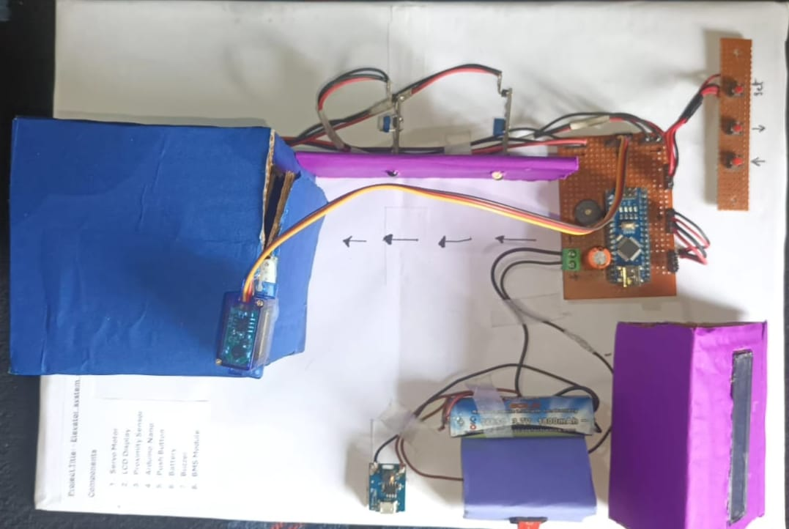
The implementation of the Elevator System with Load Detector successfully demonstrated the capability of integrating load sensing technology with microcontroller-based elevator control. The prototype consistently detected variations in weight using the load cell and HX711 amplifier module, providing accurate and stable readings throughout testing. The system responded correctly by preventing elevator movement during overload conditions and activating both visual and audio alerts to notify users. This result confirms the effectiveness of the programmed safety logic and validates the importance of automated load monitoring in elevator applications. During trials, the motor driver and DC motor operated smoothly, enabling the elevator cabin to move between floors without vibration or sudden jerks. The limit switches accurately identified floor positions, allowing the microcontroller to stop the elevator at the intended floor precisely.
Under normal load conditions, the system permitted uninterrupted movement and delivered consistent performance across multiple test cycles. In overload conditions, the elevator was observed to halt immediately, showing reliable protection against mechanical strain. The system did not resume operation until the excess weight was removed, proving that the load detection logic was functioning as designed. Throughout the testing phase, the display unit successfully showed real-time weight, floor number, and overload messages, offering clear feedback to users. The buzzer alert also worked effectively, enhancing safety during overloading events. Overall, the results confirm that the proposed design meets its objectives of increasing safety, improving operational reliability, and demonstrating a practical approach to implementing load detection in elevator systems. The prototype effectively showcases how modern sensors and microcontroller technologies can be used to enhance elevator safety and performance.
Chapter 6: Advantages, Applications and Future Scope

6.1 ADVANTAGES
- Prevents overloading and ensures passenger safety.
- Increases elevator lifespan by reducing mechanical stress.
- Provides real-time weight monitoring.
- Microcontroller automation reduces human intervention.
6.2 APPLICATIONS
- High-rise Residential Buildings
- Hospitals
- Commercial Complexes
- Industrial Lifts and Freight Elevators
- Smart Building Automation Systems

6.3 FUTURE SCOPE

1. Technological Enhancements
- Integration of IoT technology for real-time monitoring, remote diagnostics, and cloud-based data logging.
- Adoption of AI and machine learning to optimize elevator scheduling, predict load patterns, and improve response time.
- Use of advanced sensors like infrared people counters, ultrasonic detectors, and smart load distribution sensors for higher accuracy.

2. Improved Safety and Reliability
- Implementation of predictive maintenance systems to detect motor wear, cable stress, and overload incidents before failure.
- Addition of enhanced emergency features such as automatic evacuation protocols and real-time communication systems.
- Integration of biometric access controls for restricted or secure building environments.

3. Mechanical and Energy Efficiency Upgrades
- Incorporation of Variable Frequency Drives (VFDs) for smoother motor control, reduced jerk, and efficient torque management.
- Use of regenerative braking systems to recover mechanical energy and convert it to usable electrical power.
- Adoption of energy-efficient materials and components to reduce power consumption and maintenance requirements.

4. User Interface and Experience Improvements
- Development of touchscreen control panels, voice-activated elevator controls, and modern HMI interfaces.
- Display upgrades for showing load, floor, and safety status in a more interactive and informative manner.
- Integration of smart accessibility features for elderly and differently-abled individuals.

5. Advanced System Integration
- Expansion into multi-elevator coordination, where elevators communicate to reduce waiting time during peak usage.
- Full integration with Building Management Systems (BMS) to allow centralized monitoring and optimization.
- Scalability for future smart building infrastructure, enabling seamless integration with automation technologies.

References
- Otis Elevator Company, Elevator Design and Safety Guidelines, Technical Documentation, 2019.
- ISO 4190-1:2011, Lift (Elevator) Installation Standards – Part 1: Electric Lifts.
- HX711 Load Cell Amplifier – Datasheet and Application Notes, Avia Semiconductor.
- Microcontroller-based automation resources from Arduino Documentation and ESP32 Technical Reference Manual.
- IEEE Research Papers on Elevator Control Systems, Load Detection, and Safety Enhancements, IEEE Xplore Digital Library.
- K. S. Shankar, “Implementation of Load Cell-Based Safety System in Elevator Design,” International Journal of Engineering Research, 2021.
- A. Gupta & R. Singh, “Automation of Elevator Control Using Microcontrollers,” International Journal of Advanced Engineering Technology, 2020.
- N. Patel, “Real-Time Load Monitoring Using HX711 Module,” Electronics For You Magazine, 2018.
- Building Management and Safety Standards – National Building Code (NBC), India, Section on Vertical Transportation.
- YouTube Tutorials and Open-Source GitHub repositories on elevator prototypes and load cell calibration for project implementation.

- Mazidi, M.A., Naimi, S., & Naimi, S. – The 8051 Microcontroller and Embedded Systems: Using Assembly and C, Pearson Education.
- Muhammad Ali Mazidi & Janice Gillispie Mazidi – Embedded Systems Design Using the PIC Microcontroller, Prentice Hall.
- Boylestad, R.L. – Electronic Devices and Circuit Theory, Pearson Education.
- Load Cell Technical Manual – HX711 Load Cell Amplifier Datasheet. Available at: https://cdn.sparkfun.com/datasheets/Sensors/ForceFlex/hx711_english.pdf
- Arduino Official Documentation – Microcontroller Programming and Libraries. Available at: https://www.arduino.cc/reference/en/
- IEEE Xplore Digital Library – Articles on elevator automation and load monitoring systems. Available at: https://ieeexplore.ieee.org/
- National Instruments – Introduction to Load Cells. Available at: https://www.ni.com/en-us/innovations/load-cell.html
- Ashby, M.F. – Materials Selection in Mechanical Design, Butterworth-Heinemann – for understanding mechanical load handling in elevators.
- Various online tutorials and simulation platforms like Tinkercad, Proteus, and YouTube Educational Channels for project prototyping and testing.
- https://docs.google.com/presentation/d/1dmmE9QRgc31I8zGn_zCVWw9WXa9e4lsX/edit?usp=drive_link&ouid=107190188439644560420&rtpof=true&sd=true

Mini-Project Team Profile
Sl.  No | Photo | Name and USN | E-mail ID | Mobile No.
1 |  | Akhila.V  3BR23EE009 | akhilavakhilav77@gmail.com | 7892470969
2 |  | E.P.Sindhu  3BR23EE023 | sindhuep28@gmail.com | 8310245656
3 |  | Avinash Reddy D  3BR23EE013 | Davinashreddy7@gmail.com | 7411041517
4 |  | Basavaraj kori  3BR23EE018 | basavarajkorii90@gmail.com | 7026870779
ELEVATOR SYSTEM WITH LOAD DETECTOR |  |  | https://docs.google.com/presentation/d/1dmmE9QRgc31I8zGn_zCVWw9WXa9e4lsX/edit?usp=drive_link&ouid=107190188439644560420&rtpof=true&sd=true |   https://www.mediafire.com/file/7kbrk3je08xifxp/InShot_20251213_005821554.mp4/file



